Roadmap
11 October 2020
1 For Nahuat Lexicon
Please add the following white lettering to the Mesolex header as indicated. Actually the lettering should be taken from the sub-portal name and the module. So it should be (note plural, lexicons)

Nahuat of the Sierra Nororiental de Puebla | Lexicons
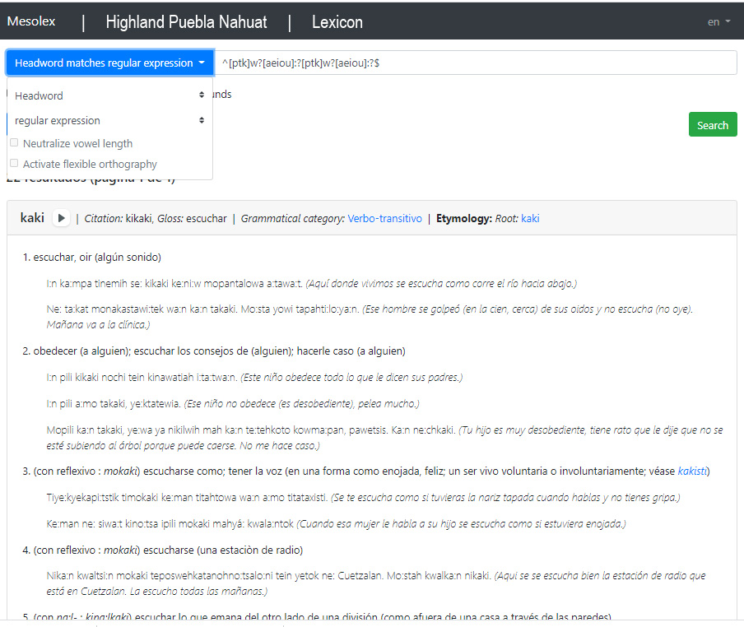

2. Make "About" / "Acerca de esta página" in red lettering.
3. Have carousel go through all 12 or so sub-portals.

