Road map
2020-09-19

Summary:
1. Keep carousel as is. Have first page the Mesolex homepage and then just go through all portals
3. Make sure to have 4 headings for each language subportal:
Lexicon [Note: search is a functionality within lexicon] Léxico
Corpus Corpus
Grammar Gramática
About/Credits Acerca de/Créditos

Corpus
For Mesolex at present this will simply be a link out to the relevant Collection in SYLARD.
Maybe ingest the SYLARD catalogue of recordings into the Mesolex subportals
Grammar
This is simply a page in the language subportal for uploading articles and other material relevant to a an academic study of the language. No primary resources.
Lexicon
Two major divisions are
Searchable (dictionary, semantically restricted lexicons, e.g., food terms, verb lists)
Documents (e.g., a pdf of Totonac plant terms)

Here is a mock-up of the design
1. Keep white band at about the height that it is here, not higher as it is now
2. Use the smaller typeface for Nahuat of the Sierra Nororiental and the same text in all others
3. Very slightly increase the transparency of the white overlay.
4. I don't like the fonts for Lexicons, Corpus, etc. but the spacing gives an idea.
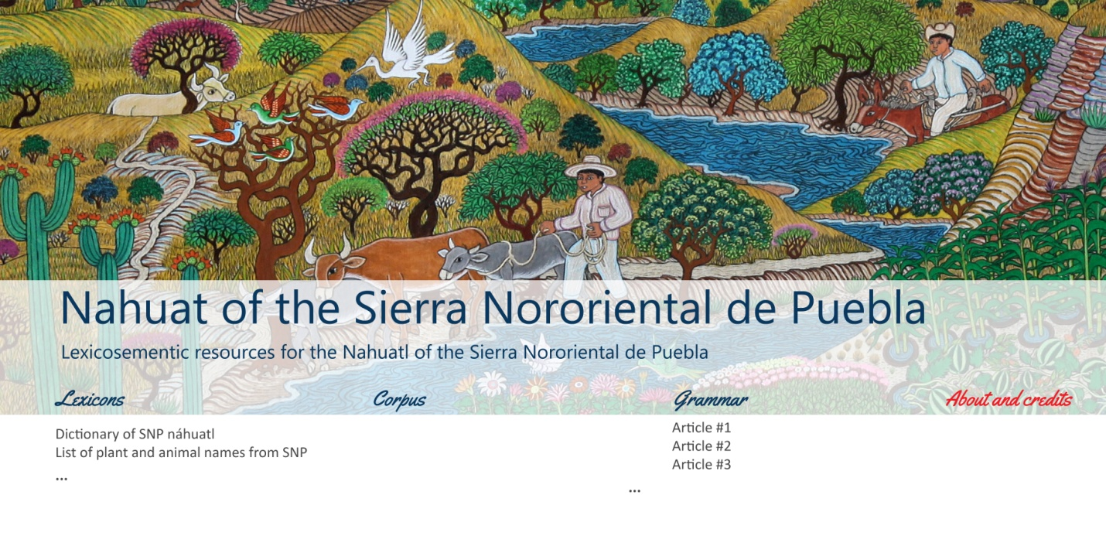 Note that for each tab we will also have a collapsible list of resources. For Sierra Nororiental de Nahuatl maybe put these in for now as an example. I will get you the documentation
Searchable dictionary Dicccionario con funciones para buscar
Summary of plant names Resumen de nombres de plantas
House parts Construcción de casas

5. Minor typo
For Pipil in the Spanish version, Náwat should have an accent.

