Inocencio Jiménez Chino

contact jonamith@gmail.com

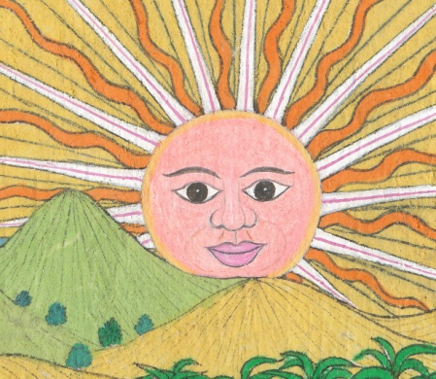 | 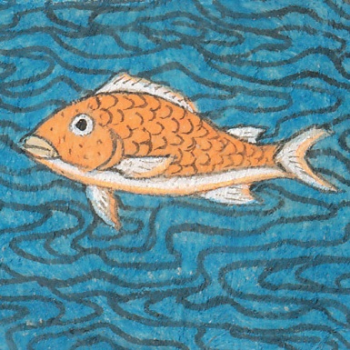

Inocencio Jiménez Chino is a corn farmer and self-trained artist from the Nahuatl (Aztec)-speaking village of San Agustín Oapan. This community, and a few nearby villages, are at the center of a genre of “tourist art” iconic in Mexico and known throughout the world as amate or bark paintings. Inocencio was twelve years old when this form of painting first emerged and soon took over village life, with virtually every family learning the skills necessary to produce dozens of homogenized and highly stylized works every week. He was eighteen when the 1968 Olympics were held in Mexico City and the government ordered hundreds of thousands of drawings, small and large, to meet the demand of the influx of visitors to Mexico.

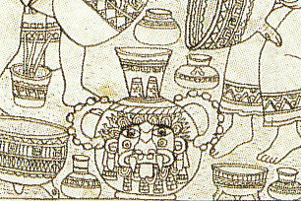
Over the following decades Inocencio continued to paint for the mass market. But at the same time, and mostly for his own pleasure, he strove to innovate and excel painting works that had not immediate market but rather started to adorn his house, a small private collection tacked to the brick walls of his modest home. Unfamiliar with the possibilities of high quality commercial brushes, he made his own out of the hairs of donkeys tied to small hollow reads. Despite these rudimentary tools, Inocencio developed a skill with detail that rivals that of any academy trained artist. The detail to the right measures about 1 inch from left to right in the original.

The first of Inocencio’s works to reach a wide audience are two line drawings that he made as part of a visual narrative to protest the proposed construction of a hydroelectric dam that would have innundated over a dozen villages in the Balsas River valley of central Guerrero, Mexico. The works were developed in collaboration with the anthropologist Jonathan D. Amith and originally planned to be given out at protests and roadblocks to raise money to support opposition to the dam. Yet the works were so striking that they became the centerpiece of an exhibition at the Mexican Fine Arts Center Museum (Chicago) and Parque La Villette (Paris). At the same time they were published in a book entitled The Amate Tradition: Innovation and Dissent in Mexican Art.

Jonathan and Inocencio became close friends. Jonathan now has a house in San Agustín Oapan and Inocencio and his wife, Florencia, have visited the United States and both helped Jonathan with a Nahuatl summer course he taught at Yale University.

Thus it was natural that when Jonathan—as part of his effort to record, transcribe and translate hundreds of hours of Nahuatl stories and narrative—obtained a beautiful Nahuatl recounting of a Brer Rabbit story, he asked Inocencio to provide the illustrations. These illustrations will be published in a bilingual (Nahuatl-English) children’s book and the original artwork (13 pieces) can hopefully be developed into a museum exhibit or gallery show.

Selected Images

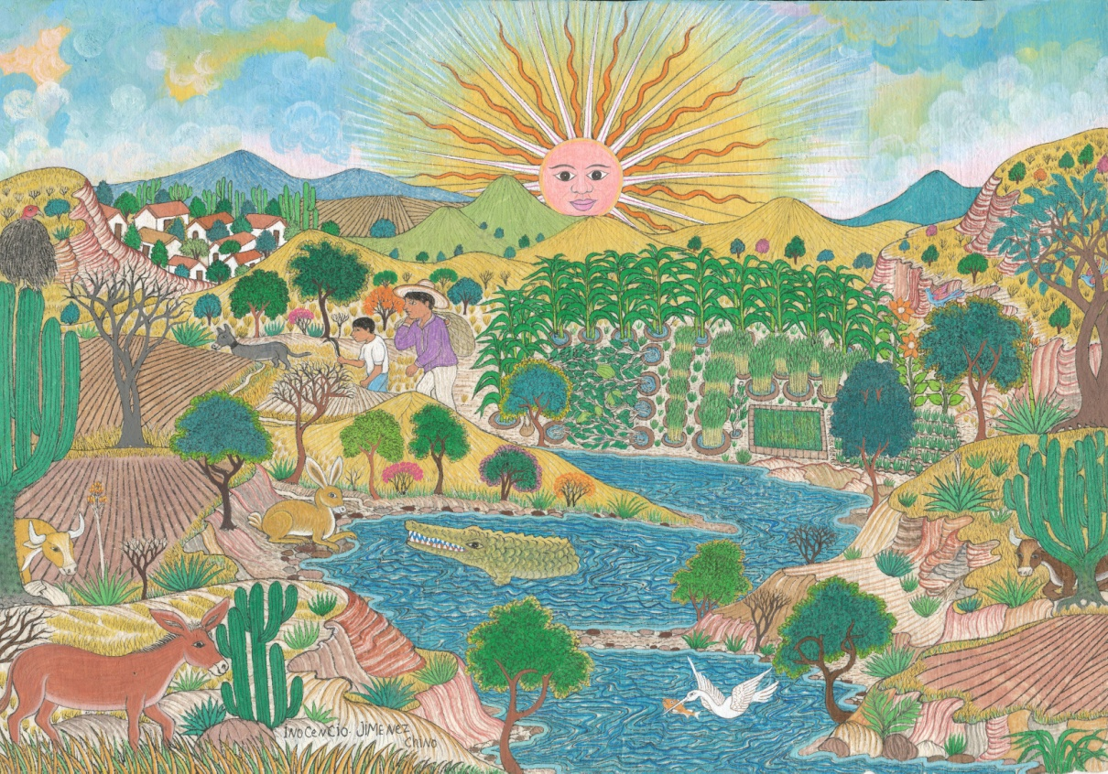

After having gazed for days at the enticing, mouth-watering garden across the river,
Uncle Rabbit has called don Caiman over to ask him for a ride to the other side.

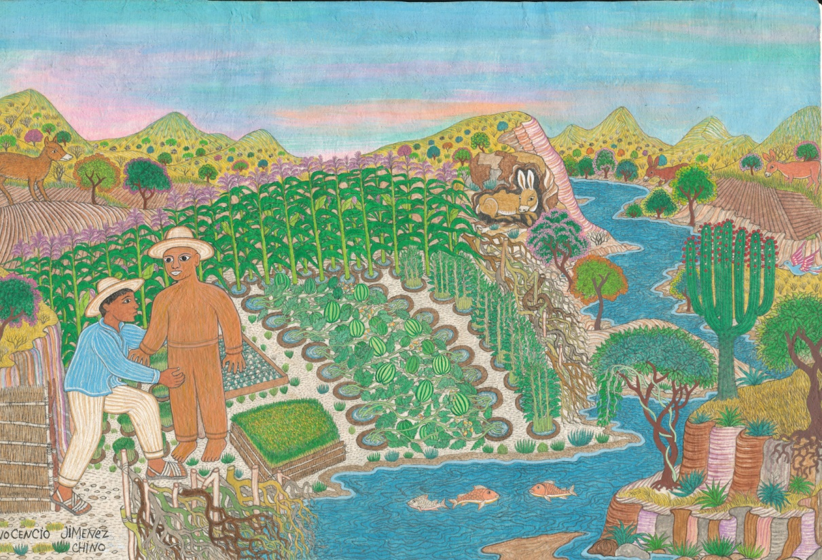

Uncle Rabbit has been sneaking in at night for a dinner of sweet potato and squash leaves. Fed up with the destruction, the gardener fashions a wax doll to scare away the intruder doing all the damage.
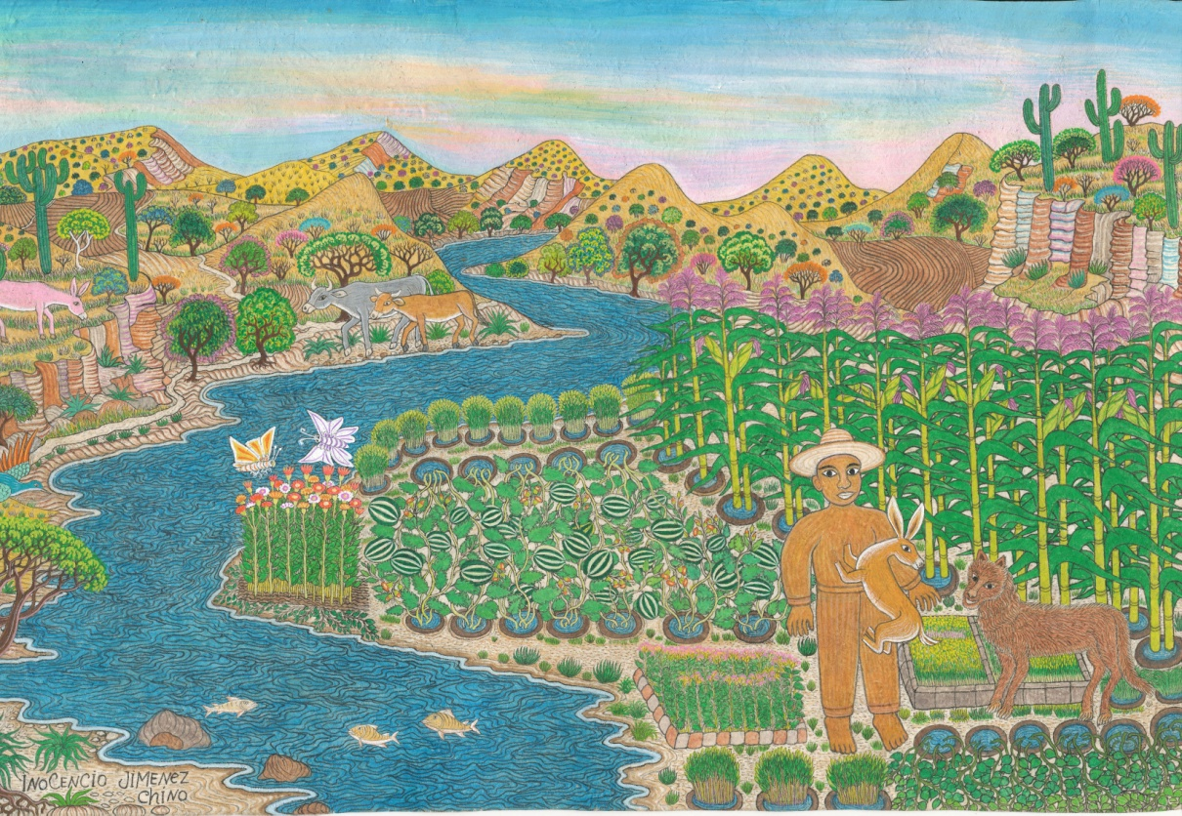

Finding the wax doll blocking his way, Uncle Rabbit chooses to fight. He hits the doll with a hard right hand and then a left. Both get stuck in the wax, making Uncle Rabbit gets even madder. He’ll teach this guy a lesson! But now, after two quick kicks, Uncle Rabbit is left helplessly hanging.

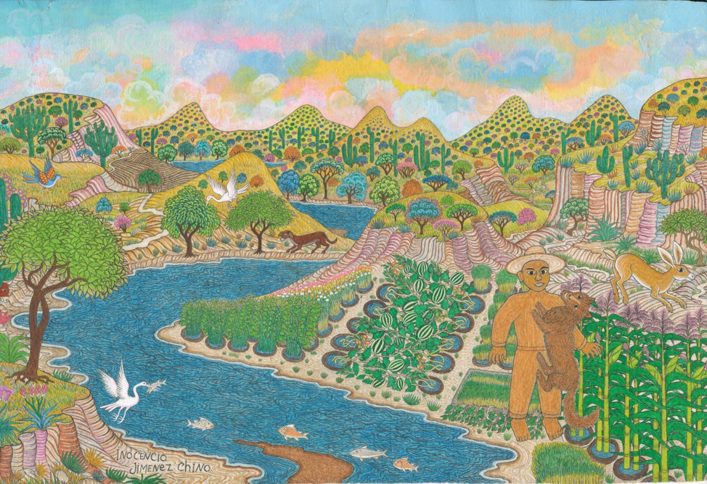

To get free, Uncle Rabbit calls out to Uncle Koyohweh, the Coyote.
“Come take my place!” he cries out, for tomorrow the gardner has promised me two chickens! I’m a vegetarian, what will I do with them? You, however, would make short work of them and have a splendid meal.
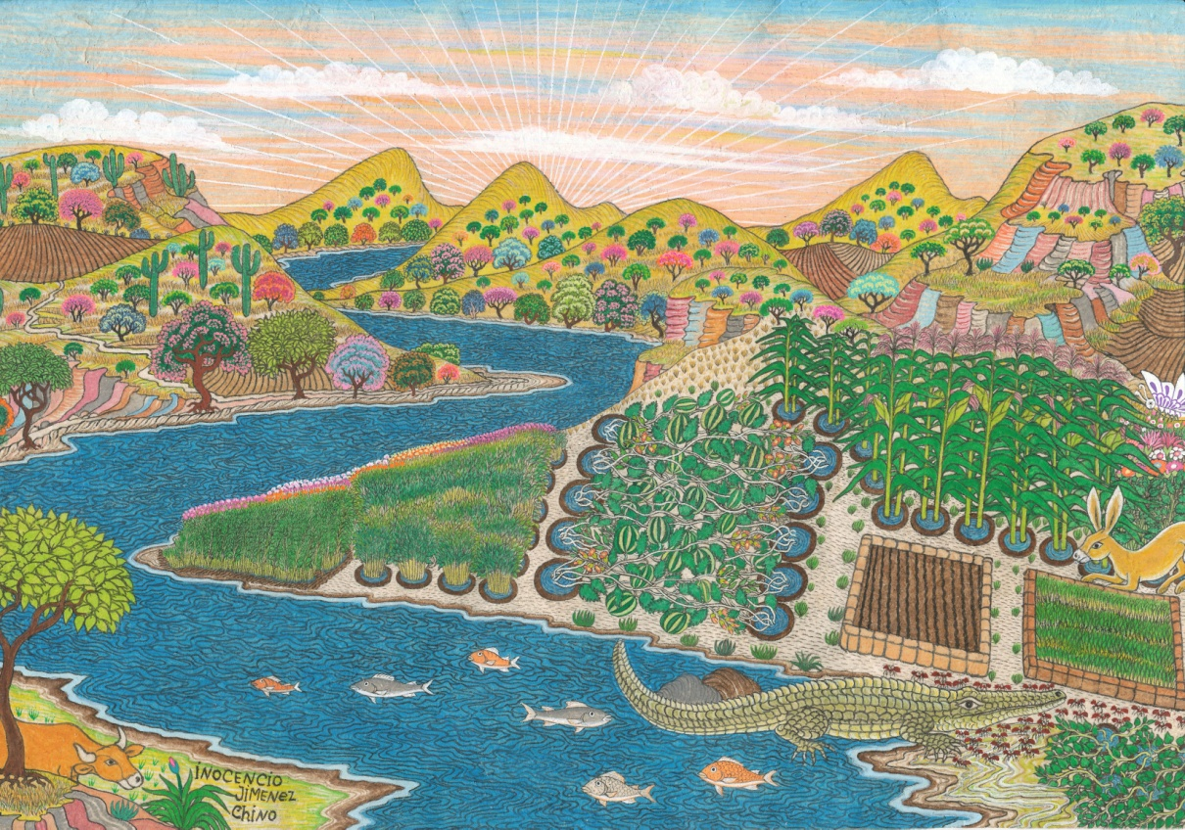

Don Caiman, however, has not been idle. Having been tricked by Uncle Rabbit to take him across the river he wants revenge. He wants to eat that rabbit. So he pretends to be dead to dupe Uncle Rabbit into getting close. “Mm,” said Uncle Rabbit out loud. “If don Caiman were really dead, he would be covered by ants.” Hearing this don Caiman calls to his friends the ants. “Come here and cover me up so he things I’m dead!”

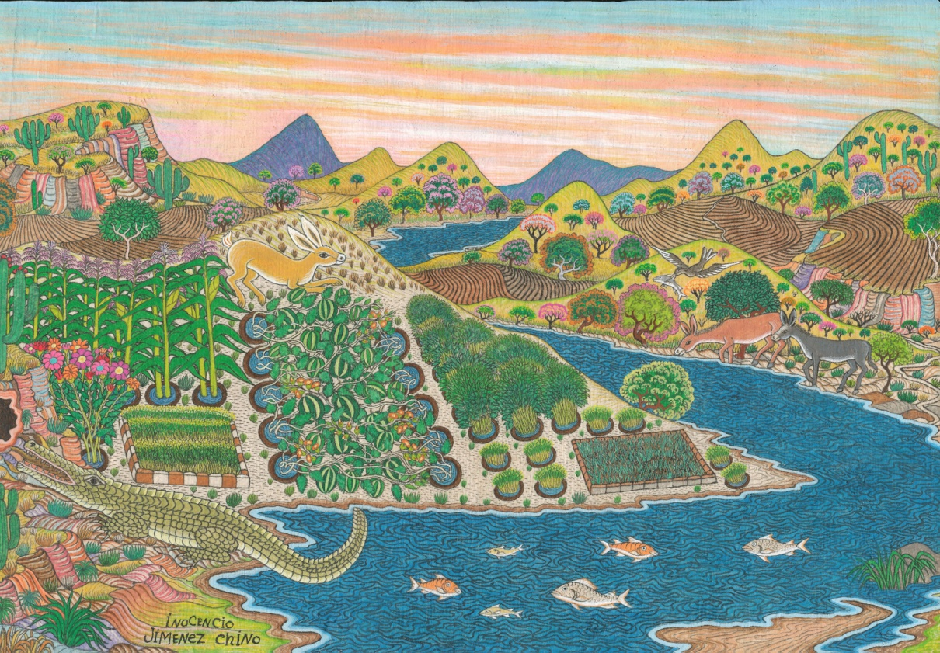

The gimmick with the ants didn’t work out. Uncle Rabbit had tricked don Caiman into getting him to cover himself with biting fire ants. So now don Caiman decided to hide with wide-open mouth behind the entranceway to Uncle Rabbit’s house. He’d walk right through the door into the reptiles waiting mouth!

