8 March 2019

Playback module improvements

Administrator will see all the ELAN tiers and can select with a check whether to upload to the server and with a pull-down menu how it should be displayed. Add the final line below
Line-by-line
Scroll box
Do not display

Vernacular name
1. Populate "Language" with languages that are associated with project in a drop-down menu and fill-in the language of the selected consultant.
2. Allow templates that are the content of a previous record to be used for a new consultant.
3. Expand Discussion to a text box. Change to Consultant comments.

Synoptic discussion tag for Occurrence Record
Create Synoptic discussion tag for Occurrence Record .Two boxes
1. Vernacular name synoptic discussion
2. Vernacular use synoptic discussion

Create module for plant functions/use. Continue development.

EAF multimedia links
Create mechanism to link multimedia (e.g., field recordings at occurrence) to occurrence record. Note: Just like field photos of a collection, this multimedia will also be available/listed at the taxon page.

On Search page please add the following filter
Limit to Specimens with Multimedia Only
Limit to Specimens with Ethnographic information Only

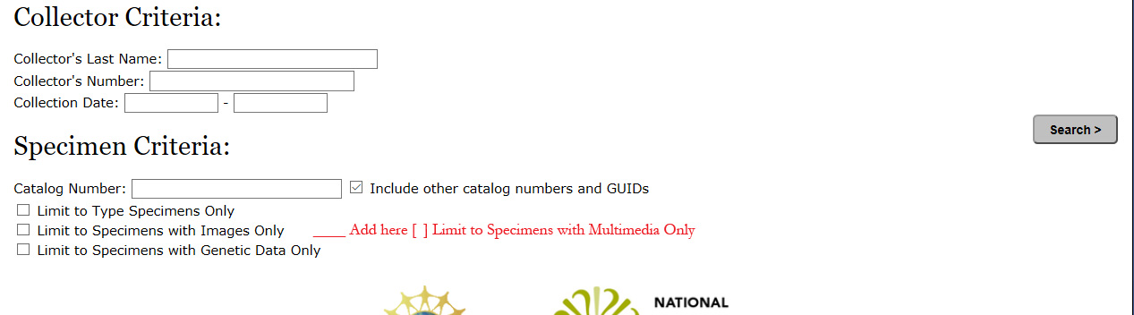

Links to multimedia:
Allow Administrator on the EAF upload page to specify species/genera/family to which the recording is should be linked OR occurrence record to which recording should be linked (by default this will also link to all Species pages that represent the Occurrence collection). I.e. like a photograph these types of recordings will be linked to the Occurrence and via the Occurrence to the Species record.

Photograph
Integrate Photo navigation with magnifier.js perhaps add two functionalities
1. Create an overlay with the photo in the center using magnifier.js
2. Look into adjusting how the navigation control works with perhaps a small thumbnail
3. Create Excel based upload/linking module for photos
Column 1 Path
Column 2 Filename
Column 3 Collection #
Column 4 Photographer
Column 5 Description

OCCURRENCE RECORDS
Examples photos
001 Cecropia obtusifolia Images 345, 743, 133
032 Cecropia obtusifolia Images 232, 464, 753, 943
183 Cecropia obtusifolia Images 434, 488, 935, 966, 989

Note that images are linked to Occurrence but accessible in bulk via the taxonomic species page.

Examples Vernacular names
Occurrence record
Vernacular names
001 Cecropia obtusifolia Joe Names atscatl kwawit
Sally Names xys
Mary Names abc
Synoptic summary by Administrator Joe and Sally xxxxx but Mary is from ….
Annotation field: Open to registered users 1, 2, 3, 4.

In Comments Tab for Occurrence Record registered can leave comments for
Species identification and related issues
Vernacular name
Plant use

Uses

001 Cecropia obtusifolia Joe Uses firewood for low temperature burning
Sally Uses living fence
Mary Uses firewood
Synoptic summary by Administrator The use of firewood mentioned by Mary should probably indeed be limited to ceramics firing given the burning quality of C. obtusifolia. See B. Brandt, 2001, making ceramics ….
Annotation field: Open to registered users 1, 2, 3, 4.
In Comments Tab for Occurrence Record registered can leave comments for
Species identification and related issues
Vernacular name
Plant use

Species records
Links / display of all photos related to a species is a existent functionality
Create tabs as species/taxonomic record
1. Description of plant
2. Discussion of names: Summary of information in all occurrence records
3. Discussion of use: Summary of information in all occurrence records
4. Link to multimedia

Longer term
Resource database (books, articles, ms) input form
Rethink links among words
Drifted cognates
Drifted calques
Allow shared functions to be input along with cognates, loans and calques,
Start Beta testing of Yoloxochitl Mixtec and Totonac data entry

